**Assignment Document**

**Objective** – Power BI Desktop - End to End Workflow

**Source** - Netflix

**Analytics** – Questions based on DAX, Visual creation, Slicers and overall dashboard design

**Report/Dashboard** – Netflix Report

1. Using Power Query Editor in Power BI, List down the transformation steps applied on the Netflix dataset to clean and transform it. Transformation steps such as splitting columns, changing data types, trimming text values and so on. Explain the purpose of each step and how it improves data quality for analysis.
2. Deep dive into page formatting the background should be black & there should be 4 report pages name as (Home, Global Analytics, India Analytics, About us). Give summary in-Home page about Netflix.
3. Create an area chart BI that displays the amount of content by release year. It should provide information about total content, total movies and Total TV shows. Use DAX functions such as CALCULATE and DISTINCTCOUNTNOBLANK to compute the measure. Explain how these functions work and why they are used in this context.
4. Create a donut chart in Power BI to represent the total content distribution. Show the total content in the centre of the donut chart. Categorize the content (e.g., by type such as Movies vs. TV Shows, or by genre) to give meaningful insights. Explain your choice of category and how the donut chart helps visualize the proportion of each group within the total content.
5. Create KPI Cards showing total content, total movies and total TV shows at global level and Country level (India)
6. Add slicers for 'Country' and 'Year', a text filter for 'Title', that drive all the visuals. Explain how each visual element supports data exploration and improves user experience and explore more Visual interactions with the slicers.
7. Create a clustered bar chart to display the top 10 countries based on total content. Create a clustered bar chart to display Top 10 genre based on content.  
   Create grid for displaying title name, release year, director and description.
8. Implement the above visuals using bookmarks to allow users to toggle between different visual views. Describe how bookmarks enhance report navigation and interactivity
9. Calculate total rating by movies, and Total rating by TV shows using Treemap implement the two visuals using bookmarks.
10. Create buttons in your report to enable users to navigate through different summary and detailed report pages.
11. Create a line chart to display rating by content at Country level (India)
12. Create an area chart to display amount of content added over the Years on Netflix India
13. Add a hyperlink in your report (About us page) that redirects users to the official Netflix website. Explain how hyperlinks can be used in reports to connect external resources and enhance user navigation.
14. 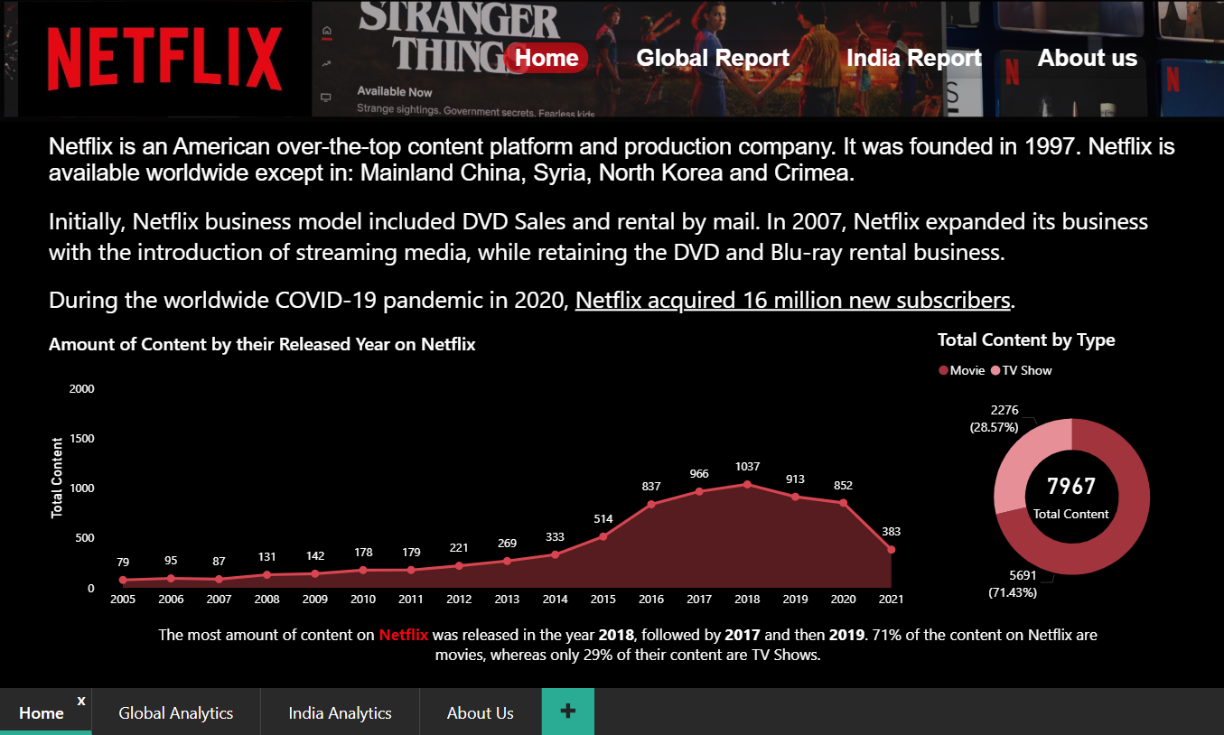Below are the dashboard screens for reference:

**Below are the Images required for creating dashboard:**

 